EXPERIMENT NO 12
Determination and plotting of magnetic and electric field intensity due to infinite long conductor at any specific point located at H

Aim:
To write program for Magnetic field intensity of infinite long conductor using SCILAB.

Software required:
- SCILAB version 6.0.1

Program:

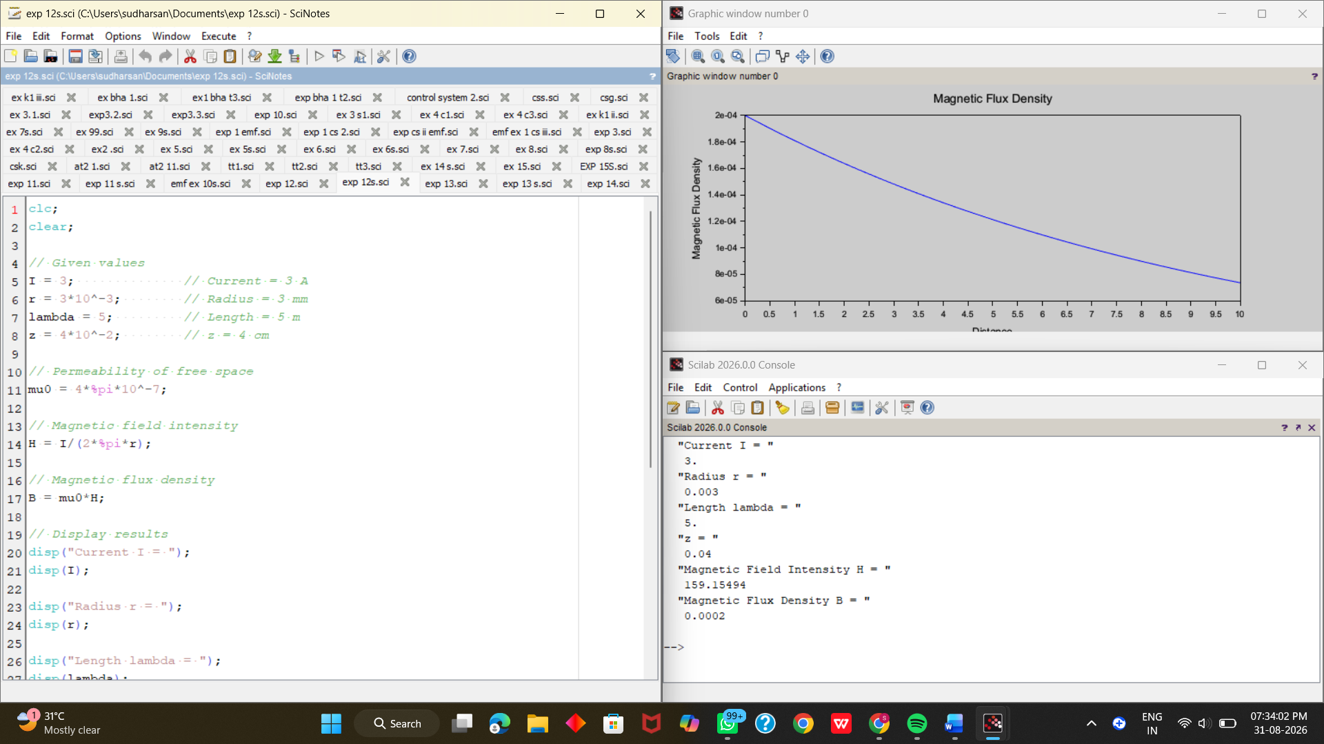



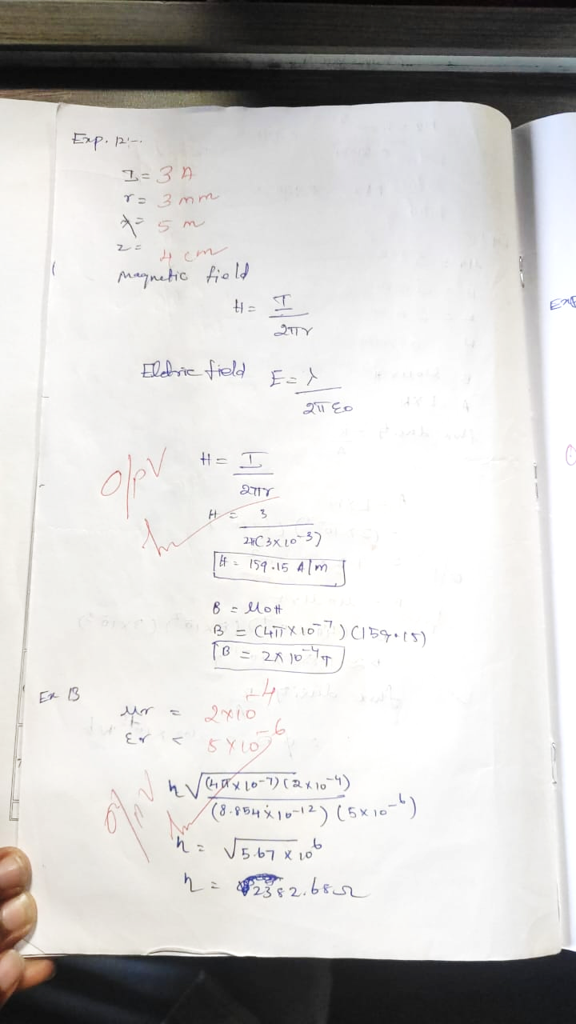

Case 1: To examine how the magnetic and electric field intensities change with varying distances from an infinitely long current-carrying conductor.

Program:
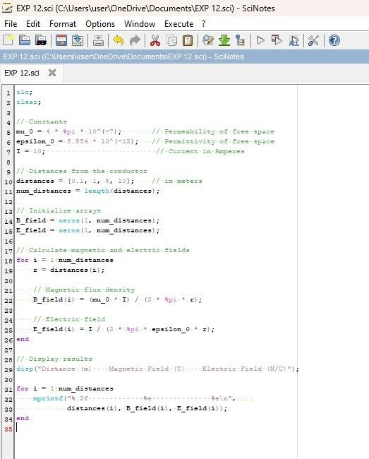

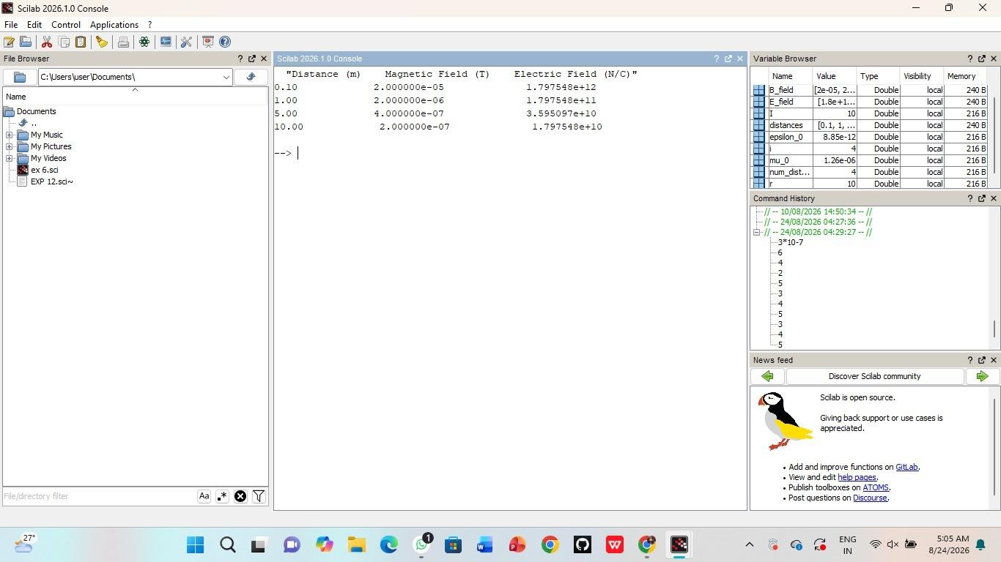
Case 2:To study how the magnetic and electric field intensities change for an infinitely long conductor at a fixed distance H but with varying currents.

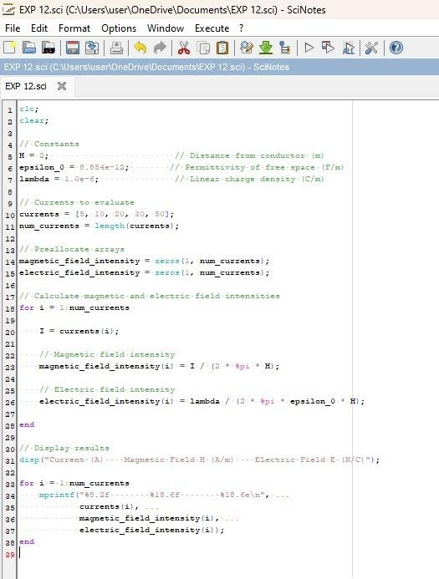

Output:
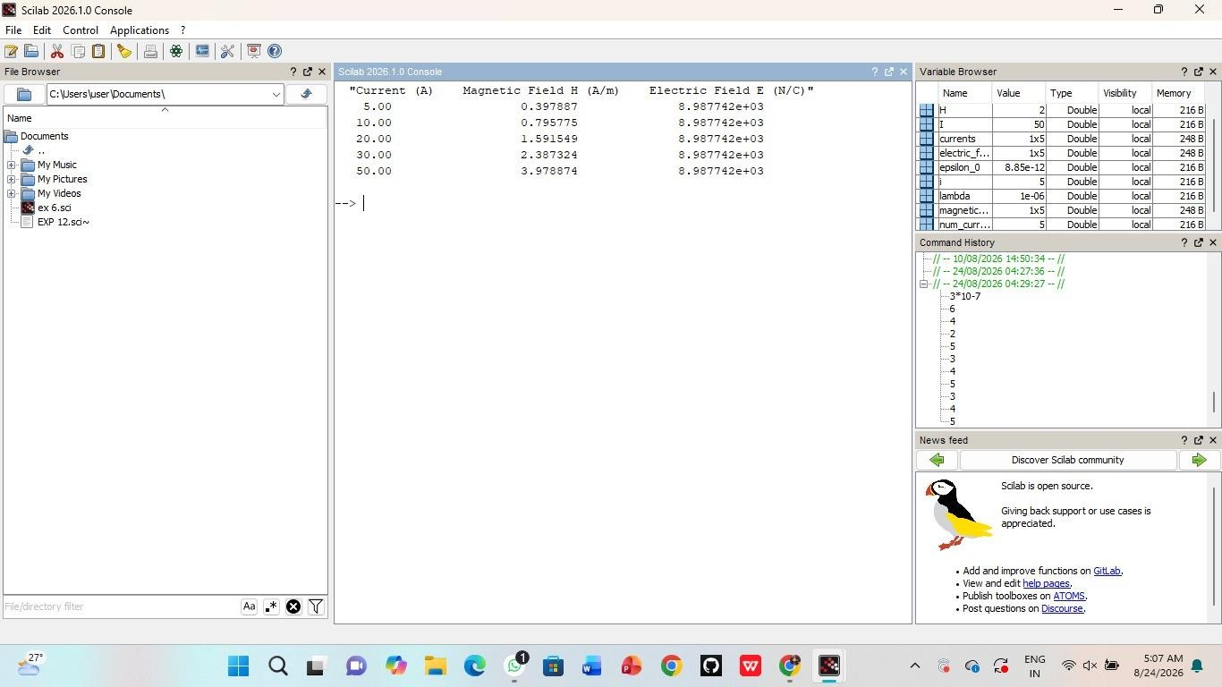
Case 3:To analyze the magnetic and electric field intensities due to an infinitely long conductor when there is a potential difference (voltage) across the conductor, simulating a capacitive effect.

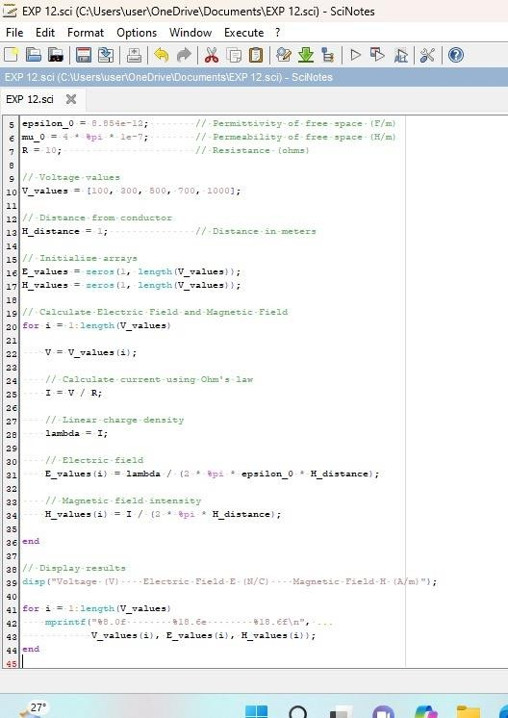

Output:
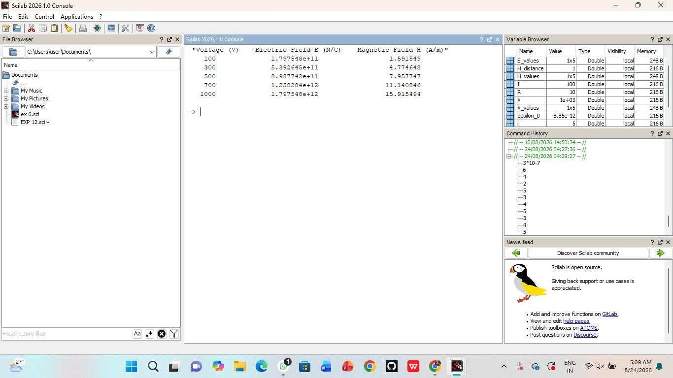
Result: Thus the program was verified for the magnetic and electric field intensities due to infinitely long conductor.

